SOLVING EQUATIONS
Pearson Edexcel - Tuesday 21 May 2019 - Paper 1 (Non-Calculator) Foundation Tier

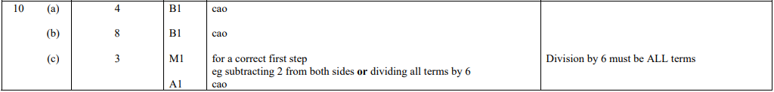

Pearson Edexcel - Monday 12 November 2018 - Paper 3 (Calculator) Foundation Tier

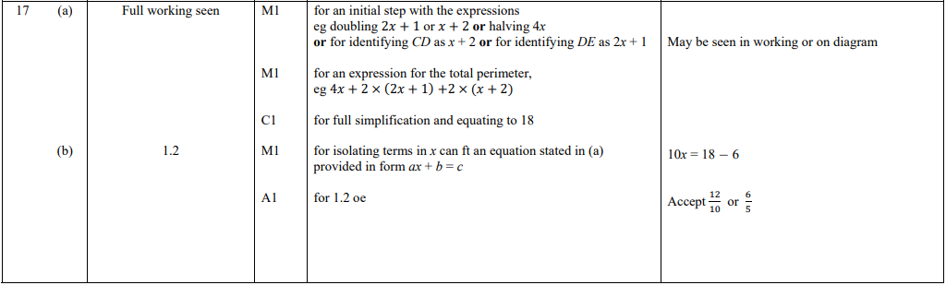

Pearson Edexcel - Thursday 7 June 2018 - Paper 2 (Calculator) Foundation Tier

Pearson Edexcel - Tuesday 12 June 2018 - Paper 3 (Calculator) Foundation Tier

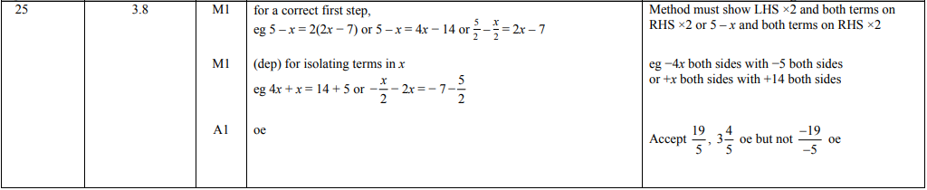

Pearson Edexcel - Monday 6 November 2017 - Paper 2 (Calculator) Foundation Tier

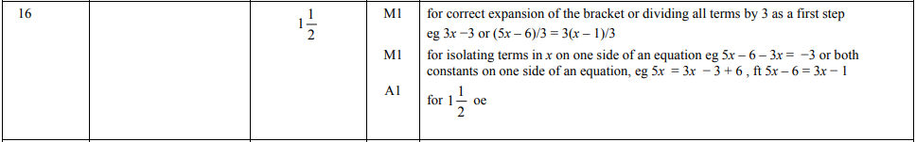

Pearson Edexcel – Specimen 2 - Paper 1 (Non-Calculator) Foundation Tier

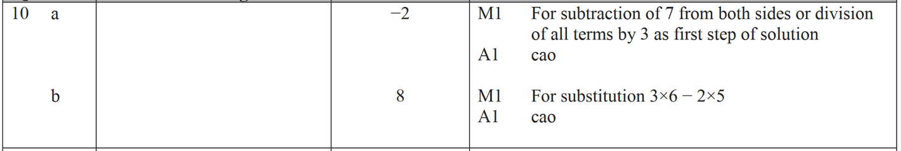

Pearson Edexcel – Specimen 2 - Paper 2 (Calculator) Foundation Tier

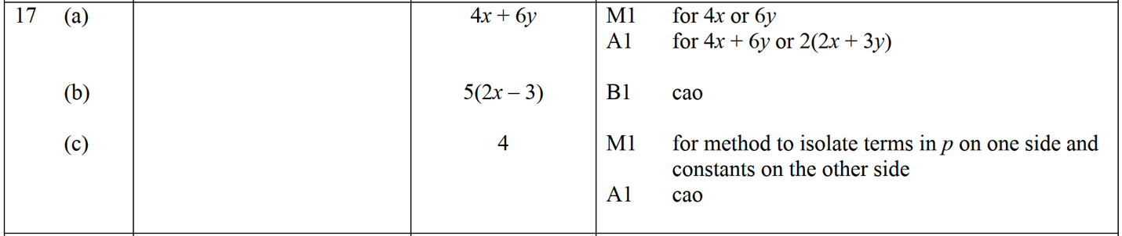

Pearson Edexcel – Specimen 1 - Paper 2 (Calculator) Foundation Tier

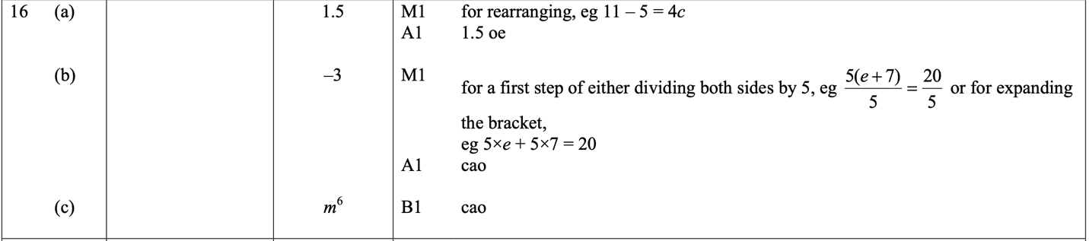

Pearson Edexcel – Specimen 1 - Paper 3 (Calculator) Foundation Tier

OCR – Tuesday 03 November 2020- Morning - Paper 1 (Calculator) Foundation Tier
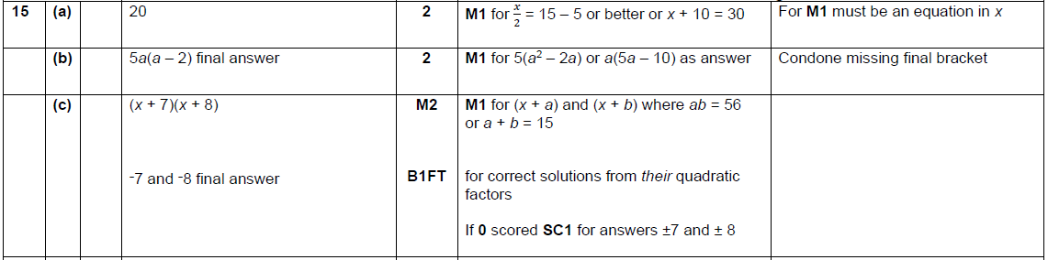

OCR Thursday 05 November 2020- Morning (Non-Calculator) Foundation Tier
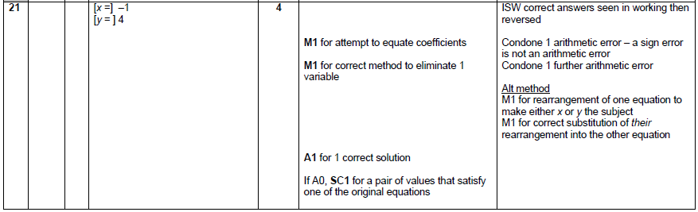

OCR November 09 November 2020- Morning (Calculator) Foundation Tier
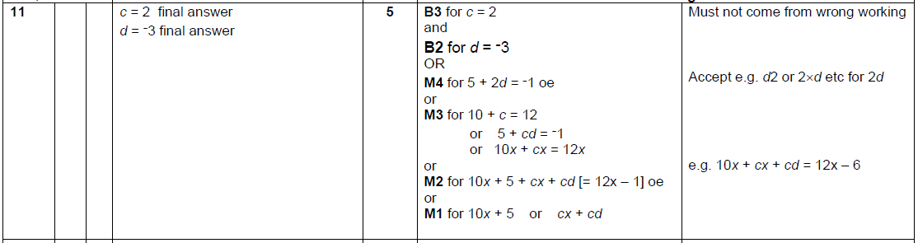

OCR Tuesday 6 November 2018 – Morning (Calculator) Foundation Tier

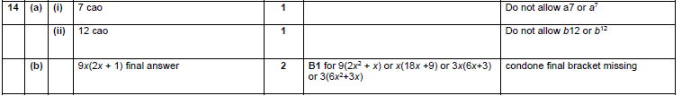

OCR Monday 12 November 2018 – Morning (Calculator) Foundation Tier
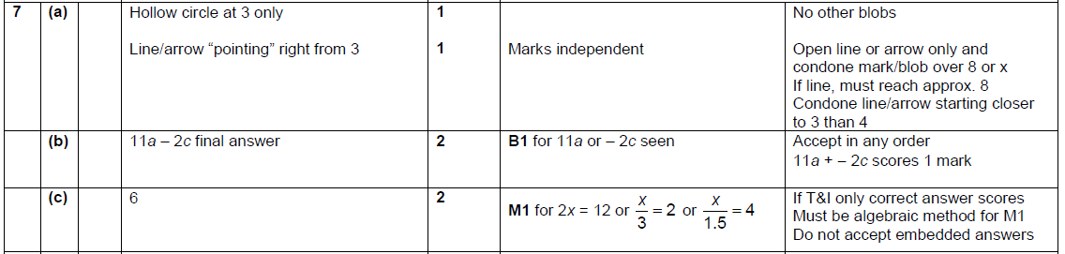

OCR Monday 24 May 2018 – Morning (Calculator) Foundation Tier

Pearson Edexcel – Sample Papers - Paper 1 (Non-Calculator) Foundation Tier

OCR Sample Question Paper 1 – Morning/Afternoon (Calculator) Foundation Tier

OCR Sample Question Paper 2 – Morning/Afternoon (Non - Calculator) Foundation Tier

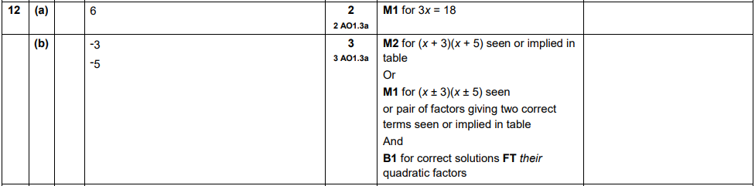
OCR Sample Question Paper 2 – Morning/Afternoon (Non - Calculator) Foundation Tier

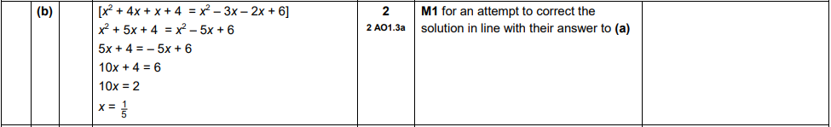

OCR Sample Question Paper 3 – Morning/Afternoon (Calculator) Foundation Tier

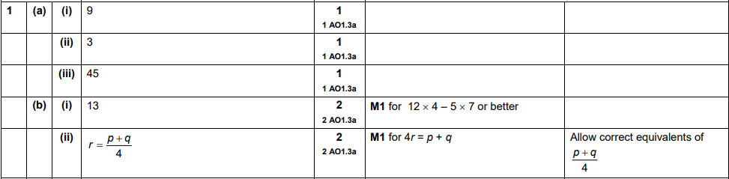
AQA Tuesday 19 May 2020 – Morning (Non-Calculator) Foundation Tier

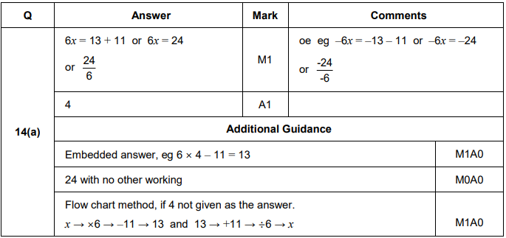
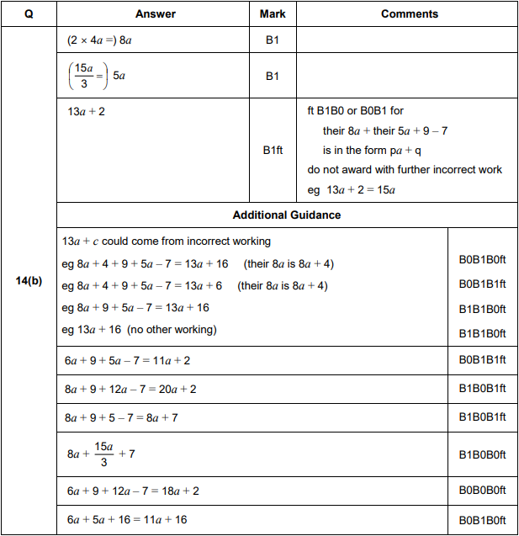

AQA Thursday 4 June 2020 – Morning (Calculator) Foundation Tier

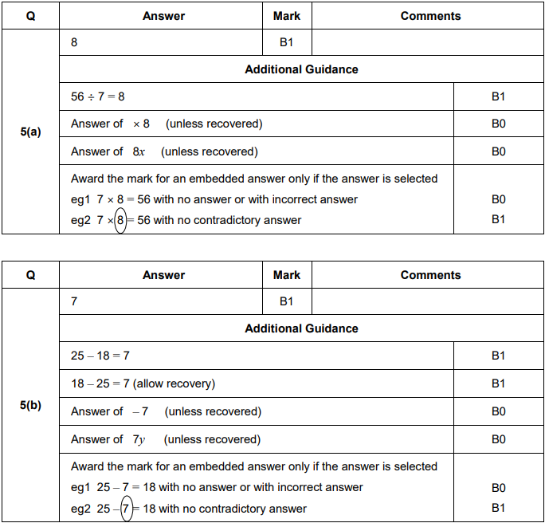

AQA Tuesday 21 May 2019 – Morning (Non-Calculator) Foundation Tier

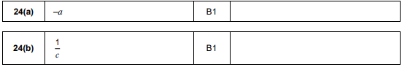
AQA Thursday 8 November 2018 – Morning (Calculator) Foundation Tier

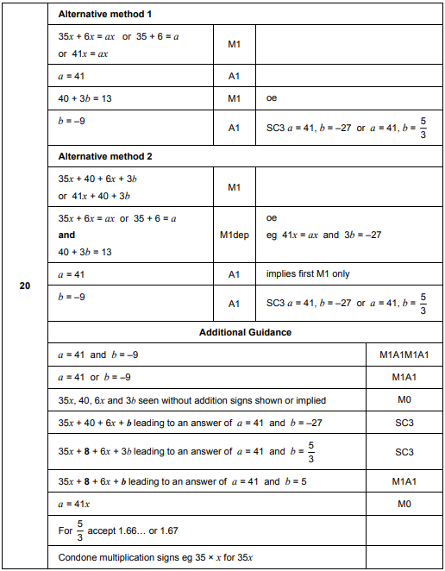

AQA Monday 6 November 2017 – Morning (Calculator) Foundation Tier

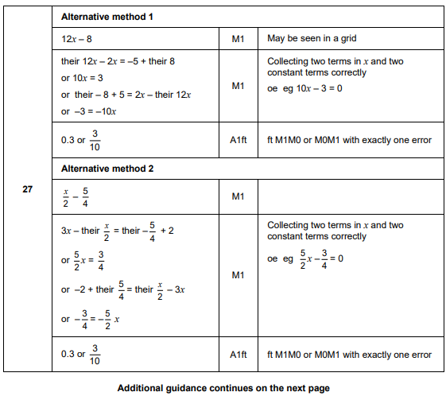
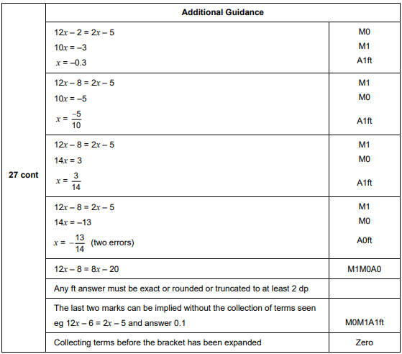
AQA Sample Paper 2– Morning (Calculator) Foundation Tier

